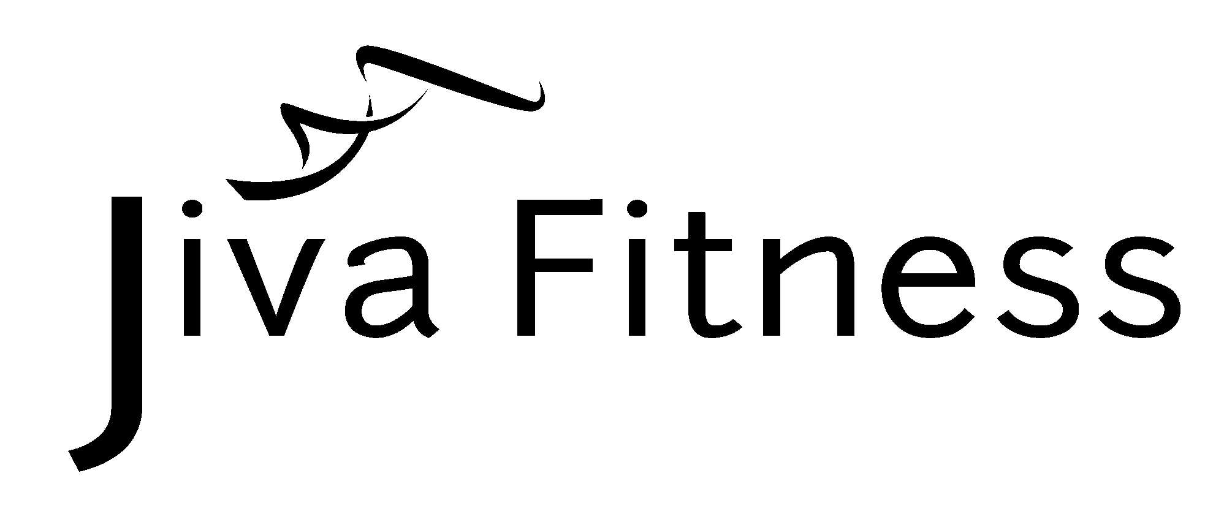
Name: ______________________________________
Choose to Change Commitments
“I choose to change”

One of the big downfalls of people attempting to change, is that they try to take on too much at once. Reaching your ultimate goal will come from accomplishing a lot of little changes. This challenge is about focusing on those smaller things that will take you a few steps closer to your goal. Choose 1-3 things to work on for 4 weeks. When those behaviors become habit, move on to new ones. Wear your free “I CHOOSE TO CHANGE” wristband as a reminder of your commitment. *It is important to note that, while you may have committed to certain behavior changes for this time period, if you break that commitment for any reason, it’s not over. Don’t give up on it. Don’t guilt yourself about it. Don’t let it define you. Forget it and begin again. Don’t let perfect get in the way of good.

I will… (Circle 1-3 items listed below or add your own.)

____Work out ____ times per week
____Not eat after dinner
____Eat protein with every meal
____Go for a walk after dinner ____ times per
week
____Not drink alcohol during the week
____Not eat while watching tv
____Get 8 hours of sleep
____Eat breakfast
____Preplan my dinners for the week
____Single serving only at dinners
____Not sitting more than an hour without getting
up and moving around
____Take the stairs not the elevator
____Park farther away and get the extra walk
____Write down 3 things that made me happy at
the end of each day
____Take 5 minutes to just sit and breathe as soon
as I get home from work
____Preplan my snacks for the week
____Drink at least eight 8oz glasses of water each
day (roughly 2 liters)
____Eat at least ____servings of fruits or
vegetables per day
____Not eat processed food ____days per week
____ Start a negative self-talk jar and pay ____
every time I catch myself talking badly to
myself
____ Avoid “white” foods i.e. white rice, white
potatoes, white bread, etc.
____ _____________________________________
____ _____________________________________
____ _____________________________________
____ _____________________________________
____ _____________________________________
____ _____________________________________
____ _____________________________________
____ _____________________________________
____ _____________________________________
____ _____________________________________

